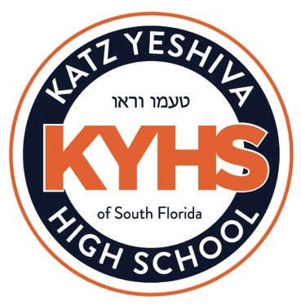
COMMUNITY SERVICE REQUIREMENTS AND POLICIES
The community service program at KYHS aims to encourage students to be meaningfully engaged in community service in ways that foster their own independence. We encourage students to complete their requirements in ways that will serve others and as a result provide meaningful experiences for themselves. Please pay careful attention to the policy guidelines below. Please keep in mind that just because something has been accepted in the past, it may not meet the current guidelines, and may not be accepted this year. If you have any questions, please contact the community service coordinator.

We are proud of our students who engage in community service over the summer but please note that for purposes of our community service requirements, we only award credit for hours performed during the school year.

There are two levels of fulfillment. Students may choose which category of community service they will fulfill.

- Honors - A student who volunteers for a minimum of 12 hours each trimester, (not rolled over from previous trimesters) and submits them on or before the last day of each trimester, will earn an A for the year-end grade and receive an honors designation for community service on his/her transcript. In order to earn an A, a student must meet the criteria for all three trimesters.

- Pass - In order to earn a grade of “Pass” for the year a student may volunteer in one of two ways:

Activity Based:
Students must perform a total of nine community service activities over the course of the year. Three activities should be performed each trimester. The idea of a community service activity is that a student takes the time to volunteer on nine separate occasions regardless of the time they spend there. For example, a student visits a nursing home nine times. Even if they only stay for one hour each time, the fact that they went nine different times to volunteer allows them to meet their community service requirement.

Hours Based:
Students must complete a total of 21 hours over the course of the year.

Examples of approved opportunities for community service include:

- Unpaid aid given to communal non-profit Jewish or general organizations. Some examples of acceptable community service facilities are hospitals, synagogues, old age homes, schools, and communal or charitable organizations.

- Volunteering for Katz Yeshiva High School after school hours can count for a maximum of 10 hours or 4 community service activities per year. Examples include:

    - Weekly publications, Student Council, Video Production, Yearbook etc.
    - Student leaders for non-weekly publications can receive up to 3 hours per year.
    - Peer note taking counts for 1 hour per subject per trimester, up to a maximum of 7 hours per academic year.

- Hours performed assisting individuals must be organized through Mrs. Stein and approved by her in advance.

- Boys who lain on Shabbat and Yom Tov will receive 30 minutes per aliyah.

Students may not receive payment for any of the above services if they want them to count as community service. However, just because a student is not paid for assisting someone does not mean that it is automatically considered community service.

Students must present their hours to Mrs. Stein via email from the appropriate supervisors or on the organization’s letterhead. Signatures on blank sheets of paper will not be accepted. A parent’s signature attesting to hours performed is not acceptable.

Community service hours are due the last day of each trimester. A student who does not pass community service will have an F for the year-end grade in community service on his/her transcript.

